# PRO-C182

FACE FILTERS

# What is our GOAL for this MODULE?

We learned to apply face filters based on data collected after face detection.

# What did we ACHIEVE in the class TODAY?

● We learned about face detection.

● We learned to create and add face filters on the face.

# Which CONCEPTS/CODING BLOCKS did we cover today?

● expo-permissions

● expo-camera

● expo-face-detector

● <Camera/>, <SafeAreaView/> components

1. Create the file Filter2.js under the screens folder and import libraries.

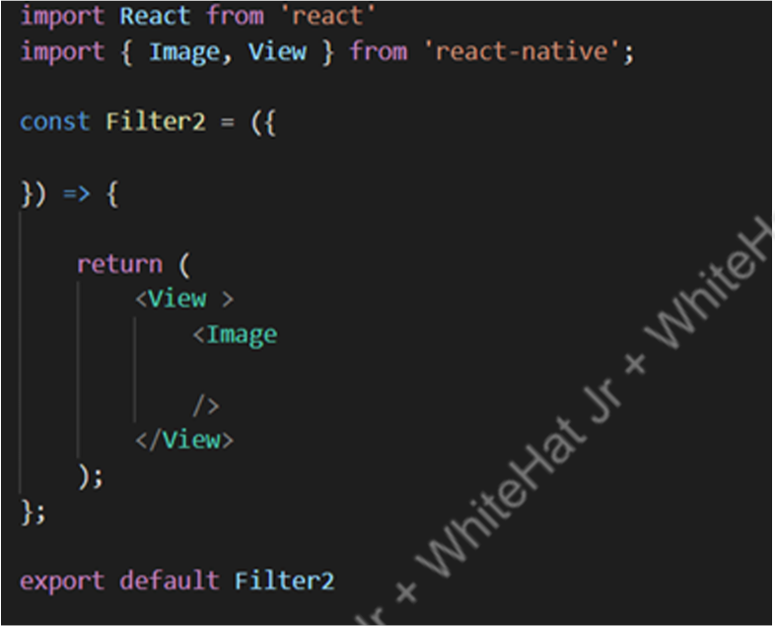

1. Add face objects and calculate angle

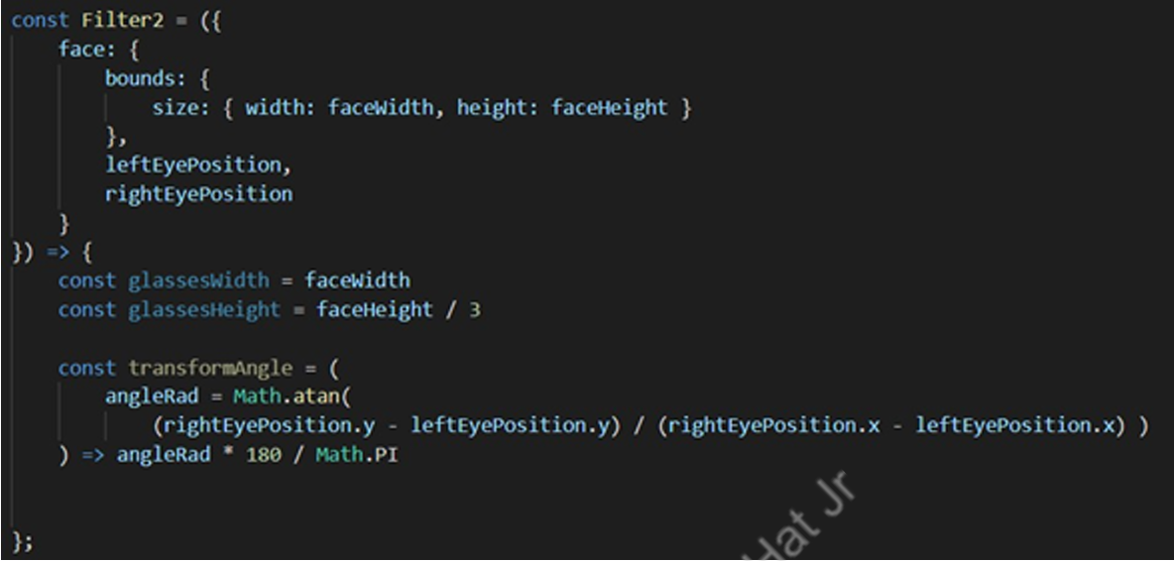

1. Write are turn method to render images

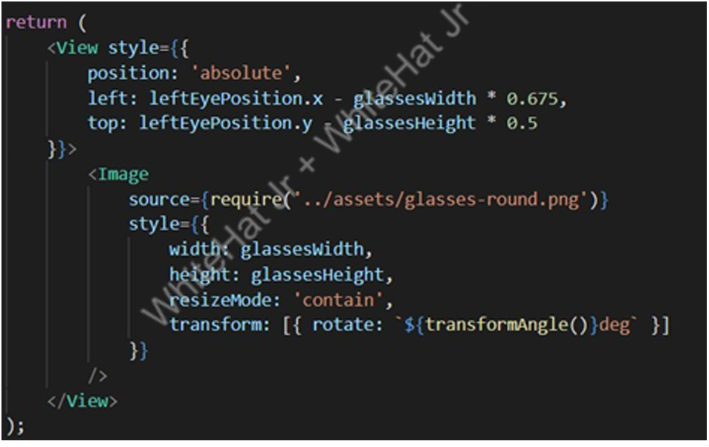

1. Import the Filter2 component and update the state in the<View>Component containing<Camera/>(below the<Camera/>).

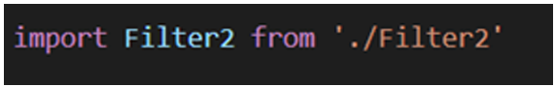

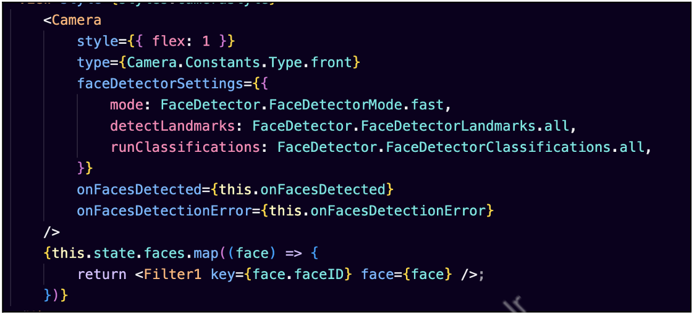

1. Test the output:

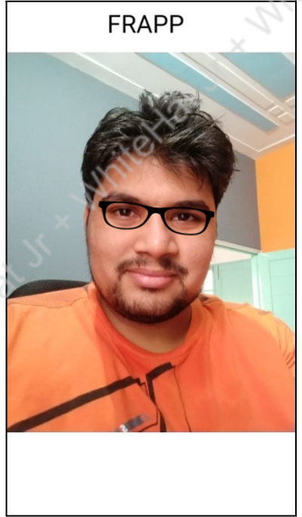

We have successfully learned to add a filter using the FaceDetector API in expo.

# What’s NEXT ?

In the next class, we will learn to add multiple filter options to try out different frames in the app based on data collected after face detection.

# EXTEND YOUR KNOWLEDGE:

● You can refer to the link below to explore more about expo FaceDetector FaceDetector